Final Exam
Courses BETA-B1PYT, INFOB2PWD and INFOMCTH
13th April 2022
Instructions
Please read these instructions carefully before starting to work on the exam.
This exam consists of 3 assignments, worth 26, 14 and 14 points, respectively, plus an additional 6 possible points for form / coding style, so you can gain up to 60 points. The grade for the exam will be calculated by dividing the points achieved by 6. For example, if you get 42 out of the 60 possible points, your grade will be a 7.
The exam will be available on Blackboard from 17:00. From then you have 3:00 hours to work on the assignments. That means that you have to submit your results by 20:00. If you are a student qualifying for extra time, you get 30 min in addition, that is, you have to submit by 20:30. Blackboard accepts late submissions, but be aware that we will deduct points from late submissions to compensate (1 point per minute delay).
During the exam you are allowed to:
- use a computer/laptop and a local programming environment (e.g. Spyder)
- use the course material (lecture notes, exercises, own and sample solutions, project work, …)
- consult existing online resources (e.g. Python documentation, StackOverflow, Google Search)
- access uu.blackboard.com for assignment download and submission
- access https://pro.quarterfall.com/ for accessing lecture material

You are not allowed to:
- use mobile phones (exception: 2FA login to Blackboard at beginning and end of exam)
- use Teams or any other text/voice/video chat programs (exception: proctoring environment)
- use e-mail programs
- use social media
- communicate with each other
- get help from other persons
To submit your solutions to Blackboard, go to “Assignment Submission” (just below “Assignment Information”. Upload your .py files there (“Attach Files” → “Browse Local Files”).
If you are on location, please have your student card and ID ready for a check.
If you have any questions during the exam, please ask the teachers supervising the exam (for students on location) or post them to the help chat in the Proctor Exam environment (for students at home).
Good luck!

Assignment 1: Trains vs. planes Stats (23 points)
The file .Flights-Trains.csv contains data to compare the costs of traveling of 6 routes along several dimensions:
- the route (Route)
- mode of transportation (Mode)
- period of six weeks before departure (WeeksAhead)
- environmental cost (EcoPassengerCO2)
- time cost to passenger (Raw travel time)
- monetary cost to passenger (Ticket price)

The file assignment1_skeleton.py contains a main program for testing purposes (don’t change!) and a number of predefined but so far empty functions. The main program loads the content of the CSV file into a Pandas dataframe. It then passes this dataframe to the functions to do something with it. Implement the functions as described in the following table:
No. | Description | Points
1 | Function get_number_of_ticket_prices  Returns the total number of ticket prices in the dataframe. | 1
2 | Function get_list_of_routes  Returns the list with the names of the different (unique) routes in the dataset. | 2
3 | Function get_total_ticket_price_for_plane_and_train  Returns the total ticket price for all routes and weeks ahead for “plane” and “train” modes separately. | 4
4 | Function get_longest_journey_duration  Returns the value of the longest journey duration. | 1
5 | Function draw_barchart_of_ticket_price_per_weeks_ahead  Draws a bar chart that shows the total ticket price each week ahead. The x axis is labeled with the week ahead, and the y axis with the total ticket price | 4
6 | Function get_three_most_contaminating_flights  Returns a dataframe that contains only the three most contaminating flight travel routes (according to the CO2 emissions). | 5
7 | Function draw_comparison_of_routes  Draws 6 line plots (one for each route) that compares per week the ticker price of planes and trains travels. Requirements:  - Plot contains as title the name of route  - Use color red for plane, color blue for train  - Include a legend for the mode of travel  Hint: Use a loop to iterate over all the routes. | 6

The output of the completed program should look something like:
There is information from 72 ticket prices in the dataset.
The analyzed routes are ['Berlin-Warsaw' 'London-Amsterdam' 'London-Marseille' 'Munich-Budapest'
'Paris-Barcelona' 'Zurich-Milan'].
The total ticket price for the plane routes is 4190 euro.
The total ticket price for the train routes is 3132 euro.
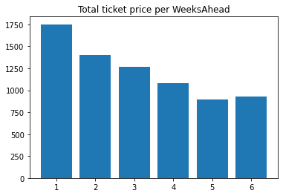
The longest journey takes 4190 minutes.
The 3 most contaminating flights are:
Route Mode WeeksAhead EcoPassengerCO2 Raw travel time Ticket price
24 London-Marseille Plane 1 311 120 121
48 Paris-Barcelona Plane 1 238 110 100
36 Munich-Budapest Plane 1 168 70 411

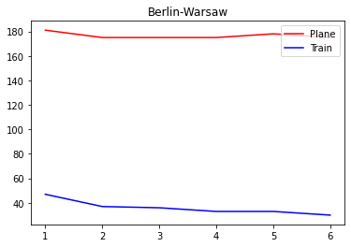
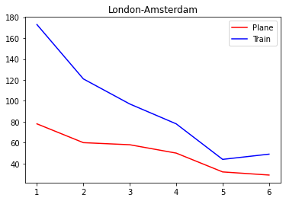
￼

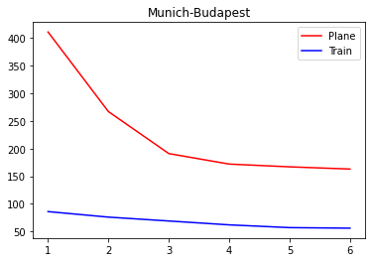
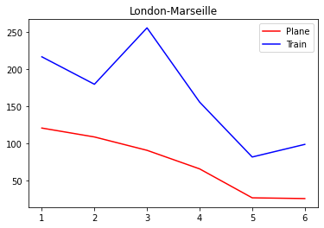
￼
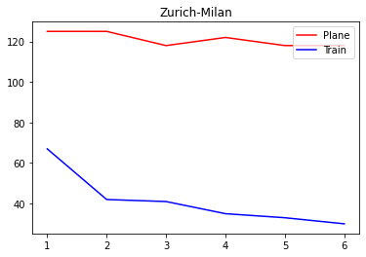
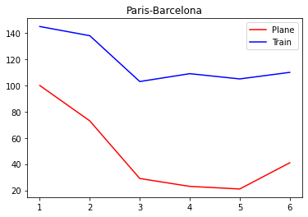
￼

￼

￼

￼

Assignment 2: GUI for Marathon Result Registration (14 points)
Use Tkinter to program a small graphical user interface for entering further data to run_statistics.csv. The interface should look something like:
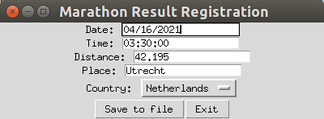
The user can enter date, time, distance, place and country (as country name, not code), and then save it to the file, or exit the interface. The file assignment2_skeleton.py already contains the main program for starting the GUI (don’t change!) and some predefined classes, functions and methods. Implement them as described in the following:
No. | Description | Points
1 | Method __init__  Sets up the elements of the GUI as shown above. It uses the Tkinter Entry widget for input of date, time, distance and place. (No need to check if the format is correct. We assume a well-behaved user here.) It uses an OptionMenu for selecting the country. This menu is filled with the countries obtained from calling the function get_country_names described below. Finally, the GUI has two buttons to save the file and exit the program when clicked. | 6
2 | Method writeButtonClick  Collects the values from the Entry fields and OptionMenu and appends them to the CSV file as a new row. | 3
3 | Method exitButtonClick  Causes the program to exit. | 1
4 | Function get_country_names  Retrieves a list of country names using the REST web services provided by  https://restcountries.com. Concretely, it uses the REST call https://restcountries.com/v3.1/region/europe to retrieve information about the countries in Europe, extracts their names, and returns them as a list.  Hint: The response string converts into a list of JSON objects. | 4

Assignment 3: Traveling Costs Management System ( points)
A nonprofit organization uses an online system to keep track about the traveling routes and their associated costs. The system contains information about the routes (with different modes of transportation), the companies that operates the routes, and the traveling costs per route. Such systems typically rely on custom classes and objects.
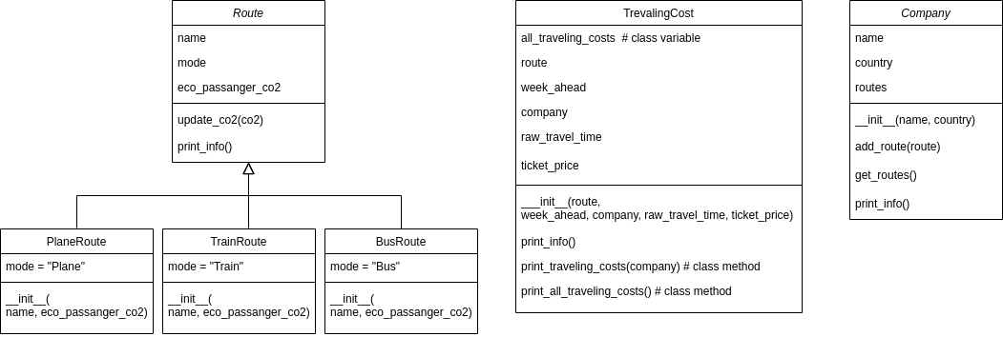
The file assignment3_skeleton.py defines the classes Route, PlaneRoute, TrainRoute, BusRoute, TravelingCost, and Company as summarized in the class diagram above, and test program (don’t change!) that demonstrates how to use them. Some methods are not yet complete. Implement them to do the following:
>>>>>>>>>>>>>>>>>>>>>>>>>
No. | Description | Points
1 | Method RunningEvent. __init__  Initializes a new running event with the name, place and date provided, and an empty list of runs. | 2
2 | Method RunningEvent.add_run  Adds the run provided to the event’s list of runs. | 1
3 | Method RunningEvent.print_short_info  Prints short information about the event (name, place and date) | 1
4 | Method RunningEvent.print_long_info  Prints elaborate information about the event (name, place, date and list of runs) | 2
5 | Method Marathon.__init__  Initializes a new Run with distance 42.195. | 1
6 | Method HalfMarathon.__init__  Initializes a new Run with distance 21.1. | 1
7 | Method Runner.__init__  Initializes a new runner with the name provided, and adds itself to the set of all runners. | 2
8 | Method Runner.register_for_run  Sets the run field of the runner to the provided run. | 1
9 | Method Runner.set_finish_time  Sets the run and time field of the runner to the provided run and finishing time, respectively. | 1
10 | Method Runner.print_results  Prints out all runners, the run they were registered for, and their finishing time. No particular order required. | 2

When all methods are implemented, the output of the program should look something like:
Utrecht Science Park Marathon, Utrecht, Spring 2022
Utrecht Science Park Marathon, Utrecht, Spring 2022
Races:
Utrecht Marathon (42.195 km)
Utrecht Science Park Halve Marathon (21.1 km)
1/4 Utrecht Marathon (10.55 km)
KWF Mini Marathon (1.5 km)
Business Run (Long) (21.1 km)
Business Run (Short) (10.55 km)
Race results:
Kasey Andrade - KWF Mini Marathon – 0:11:43
Lily-Anne Bowen - Utrecht Marathon – 2:15:04
Sid Hoffman - KWF Mini Marathon – 0:11:27
Elvis Scott - Utrecht Marathon – 2:59:34
Alistair Whitney - Utrecht Science Park Halve Marathon – DNF
Estelle Dotson - 1/4 Utrecht Marathon – 0:54:12

Form (6 Points)
In addition to the points for functionality, up to 6 points can be gained for form / (good) coding style across all three assignments.

